## horizontal line

INTRODUCTION TO ELECTRICAL ENGINEERING [19AIE104]

S1 B.TECH CSE (AIE)

COLLISION AVOIDANCE

A Project Report

Submitted By: BATCH 11

AM.EN.U4AIE20052 - NATTE SAI BHARATH

AM.EN.U4AIE20053 - NEHITH SAI VEMULAPALLI

AM.EN.U4AIE20054 - PALADUGULA PRUTHVI

AM.EN.U4AIE20055 - PAVITHRA P M NAIR

AM.EN.U4AIE20056 - PRANAV JAYASANKAR NAIR



School Of Engineering

Amrita Vishwa Vidyapeetham, Amritapuri, Kerala

# 

# ABSTRACT

A collision avoidance system, also known as a driver assistance system, is a safety system designed to prevent a collision or decrease its severity in the few seconds before it occurs.

The system designed is capable of detecting obstacles in it’s perimeter using ultrasonic sensors that will add an extra safety layer for pedestrians and will continuously display the distance between the approaching vehicle and the obstacle so vehicles can be warned or automatically stop(in case of automated), avoiding unwanted collisions.

The software used for simulation is TinkerCad. The system consists of an arduino board, ultrasonic sensor, DC motors and piezo. The ultrasonic sensor is used to detect the distance between the system and obstacles. The piezo acts as a warning mechanism for pedestrians and other vehicles.

**TABLE OF CONTENTS**

|  |  |
| --- | --- |
| S.NO |  |
| 1 | Abstract |
| 2 | Introduction |
| 3 | Components Required |
| 4 | Circuit Diagram |
| 5 | System Working |
| 6 | Appendix (code) |
| 7 | Result |
| 8 | Conclusion |
| 9 | Reference |

# INTRODUCTION

Safety features on self-driving made some great steps forward. One of them is a collision avoidance system. Many of them use radars and cameras to monitor the road and either warn the driver or take control of the vehicle when needed.

Most of the cars nowadays are using already existing technologies to avoid a collision. Since car companies start to include front-facing sensors to park a car for us. When it receives data from front-facing sensors, collision avoidance systems perform calculations to determine if there are any potential obstruction presents. If the speed differential between a vehicle and any other object is too great, then the system may be capable of doing tasks which will result in safe driving behavior. The simplest collision avoidance system will just provide warning to the driver and hopefully the driver will hit the brakes and slow down or steer away from an obstacle.

In some cases, the collision avoidance system also pre-charge breaks in conjunction with automatic braking or emergency brake assist system. That can provide the Driver with substantial amounts of braking power the moment he depressed the pedal, which may effectively reduce the severity of an accident.

Some automobile collision avoidance systems are also capable of taking over direct, corrective measurements. If one of these systems determines that a collision is imminent, it can actually engage the brakes rather than simply pre-charging them. Some of the great features included in the collision avoidance system is pedestrian detection. It highlights pedestrians in front of Vehicles and visually displays them via HUD. It works only below 30 degrees Celsius.

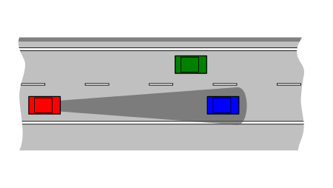

# COMPONENTS REQUIRED

|  |  |
| --- | --- |
| * Bread Board (Small) |  |
| * Ultrasonic Distance Sensor |  |
| * DC Motor |  |
| * Piezo |  |
| * Arduino Uno R3 |  |
| * Resistor |  |
| * wires |  |

# CIRCUIT DIAGRAM

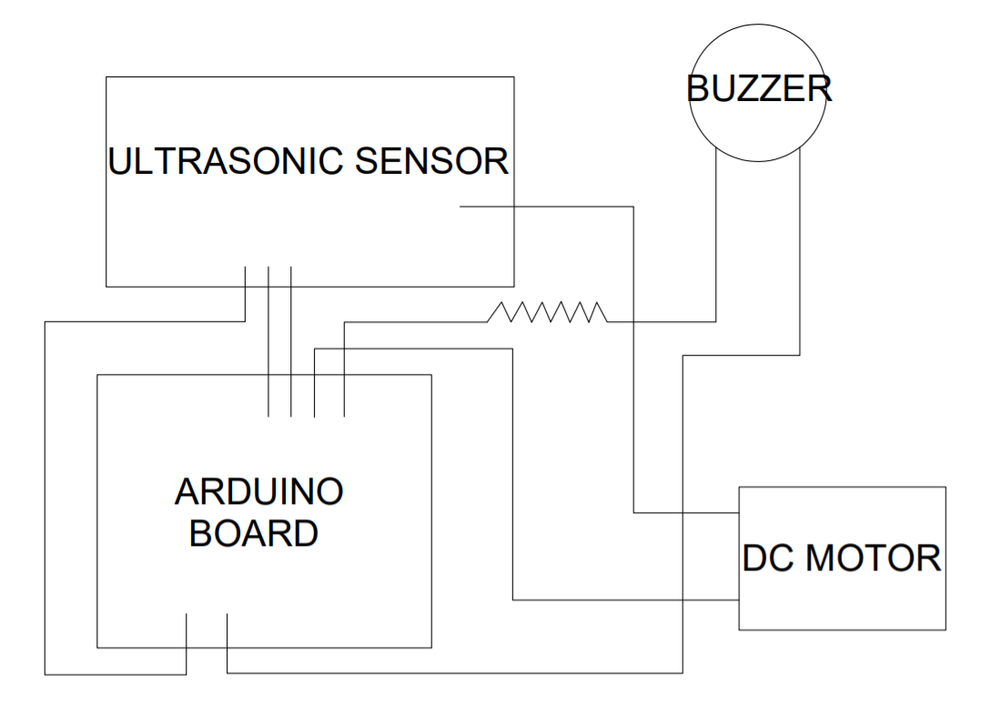

# 

# WORKING OF THE SYSTEM

Collision avoidance systems respond to situations in two different ways. The first is to alert a driver through a light, a sound, or both. Vehicles with front and rear cameras provide visual warning of obstacles. In addition to warnings and alerts, some collision avoidance systems assist drivers in mitigating imminent risks. These systems will override the driver, changing the throttle of the vehicle or applying the brakes.

Here, we can come across different case scenarios for which we can build the device for.

CASE SCENARIO:

PEDESTRIAN: have to wear a device that will measure the distance between him/her and other moving objects around it. We can use an ultrasound sensor but more can be added in order to get an 360* degree shield. Compass sensors can measure any interaction.

VEHICLE: have a communication protocol that will get real-time distance of these pedestrian devices and warn / stop automatically in order to avoid collisions. (VEHICLE - must receive values from any pedestrian device being on their path. Based on the distance the vehicle will be warned and then automatically stopped in order to avoid collision.)

TRAFFIC LIGHTS: by extending the collision avoidance system into the traffic lights systems vehicles can be automatically warned / stopped on demand but also people will be notified not to cross the street if RED light, for instance.

But, now let us only concentrate on the device built for vehicles !!

The collision avoidance system that we have developed alerts the driver of approaching obstacles. If the obstacle comes within a 100 cm(39.37 inches) distance of the ultrasonic distance sensor, a buzzing sound is produced, via a piezo which alerts the driver as well as the obstacle(pedestrian/ another vehicle). There is also an automatic emergency braking system which causes the motors to stop if the obstacle comes within the 100 cm radius.

# RESULT

Our team has developed a collision avoidance and automatic emergency braking system using an arduino chip and other simple parts which can be installed in any vehicle. When installed, a vehicle can now automatically detect and warn the driver about any obstacles and can stop itself if it gets too close to collision.

# CONCLUSION

Around 5 lakh road accidents take place in India annually wherein about 1.5 lakh people die and another 3 lakh are left crippled. According to experts, the main causes of road accidents in India are rapid urbanisation, poor safety, lack of enforcement, distracted drivers, influence of drugs or alcohol, speeding and a failure to wear seat-belts or helmets.

A cheap collision avoidance system like the one we have built can be implemented on any vehicle. This technology will no longer be restricted to just cars and can now also be added on to rickshaws and 2 wheelers.

This will greatly reduce the number of accidents that take place in our country. In the future, this technology could be expanded to include alerts for traffic signals, railway crossings, etc. NCAP's 2012 study suggests that if all cars feature a simple automated emergency braking system, it will reduce accidents by up to 27 percent and save up to 8,000 lives per year on European roads. If such a system were implemented in India the numbers could potentially be far greater due to the traffic in India being much higher.

However, technology is far from implementing a system that mitigates the possibility of accidents completely, especially when taking into consideration the chaotic state of Indian roads. Therefore, it is still the responsibility of us who drive to be careful.

# 

# APPENDIX

const int pingPin = 13; // Trigger Pin of Ultrasonic Sensor

const int echoPin = 12;// Echo Pin of Ultrasonic Sensor

const int motor = 10; // Motor Pin

const int buzzer = 11;//Buzzer Pin

void setup() {

pinMode(pingPin, OUTPUT);

pinMode(motor, OUTPUT);

pinMode(buzzer, OUTPUT);

Serial.begin(9600); // Starting Serial Terminal

}

void loop() {

long duration, inches, cm;

digitalWrite(pingPin, LOW);

delayMicroseconds(2);

digitalWrite(pingPin, HIGH);

delayMicroseconds(10);

digitalWrite(pingPin, LOW);

pinMode(echoPin, INPUT);

duration = pulseIn(echoPin, HIGH);

inches = microsecondsToInches(duration);

//100 cm = 39.37 inches

if(inches <= 39.37){

digitalWrite(motor, LOW);

tone(buzzer, 5);

}

else{

digitalWrite(motor, HIGH);

noTone(buzzer);

}

Serial.print(inches);

Serial.print("in, ");

Serial.println();

delay(100);

}

long microsecondsToInches(long microseconds) {

return microseconds / 74 / 2;

}

# REFERENCES

Works Cited

* “File:Schema ICC.svg.” *File:Schema ICC.svg - Wikimedia Commons*, [commons.m.wikimedia.org/wiki/File:Schema_ICC.svg?hcb=1](http://commons.m.wikimedia.org/wiki/File:Schema_ICC.svg?hcb=1).
* Roboauto. “How It Works? Collision Avoidance System.” *Medium*, Roboauto - Blog, 21 Oct. 2017, [blog.roboauto.cz/how-it-works-collision-avoidance-system-d05bd9807f1a](http://blog.roboauto.cz/how-it-works-collision-avoidance-system-d05bd9807f1a).
* “Smart Pedestrian Anti-Collision System (SPACS).” *Arduino Project Hub*, [create.arduino.cc/projecthub/dasdata/smart-pedestrian-anti-collision-system-spacs-3dd74c](http://create.arduino.cc/projecthub/dasdata/smart-pedestrian-anti-collision-system-spacs-3dd74c).
* <https://www.youtube.com/watch?v=sh0YTnWp3CI>
* <https://www.thehindu.com/news/national/all-about-road-accidents-in-india/article32702866.ece>
* [Google Images](https://images.google.com/imghp?hl=en&gl=ar&gws_rd=ssl)